Top of Form

Bottom of Form

**What is diabetic retinopathy?**

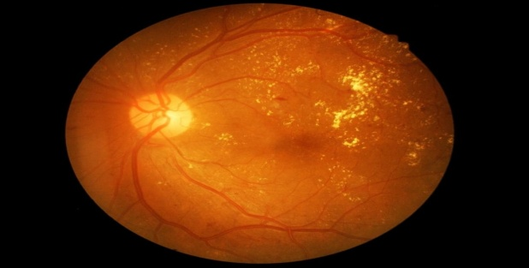

Diabetic retinopathy is a complication of diabetes that can lead to total blindness without treatment.

DR is a complication of diabetes and a [leading cause of blindness](https://nei.nih.gov/health/diabetic/retinopathy) in the United States (U.S.).

The retina is the membrane that covers the back of the eye. It is highly sensitive to light.

It converts any light that hits the eye into signals that can be interpreted by the brain. This process produces visual images, and it is how sight functions in the human eye.

Diabetic retinopathy damages the blood vessels within the retinal tissue, causing them to leak fluid and distort vision.

There are two types of DR:

* **Non-proliferative diabetic retinopathy (NPDR)**: This is the milder form of diabetic retinopathy and is usually symptomless.
* **Proliferative diabetic retinopathy (PDR)**: PDR is the most advanced stage of diabetic retinopathy and refers to the formation of new, abnormal blood vessels in the retina.

Approximately [5.4 percent](http://www.visionproblemsus.org/diabetic-retinopathy/diabetic-retinopathy-map.html) of people in the U.S. aged over 40 years have DR.

Worldwide, one-third of the estimated [285 million](https://www.ncbi.nlm.nih.gov/pmc/articles/PMC4657234/) people with diabetes show signs of DR

**Symptoms**

Diabetic retinopathy typically presents no symptoms during the early stages.

The condition is often at an advanced stage when symptoms become noticeable. On occasion, the only detectable symptom is a sudden and complete loss of vision.

Signs and symptoms of diabetic retinopathy may include:

* blurred vision
* the impairment of color vision
* floaters, or transparent and colorless spots and dark strings that float in the patient's field of vision
* patches or streaks that block the person's vision
* poor night vision
* sudden and total loss of vision

DR usually affects both eyes. It is important to make sure that the risk of vision loss is minimized. The only way people with diabetes can prevent DR is to attend every eye examination scheduled by their doctor

### Complications

Possible complications associated with diabetic retinopathy include the following:

**Vitreous hemorrhage:** A newly formed blood vessel leaks into the vitreous gel that fills the eye, stopping light from reaching the retina. Symptoms include loss of vision and sensitivity to light, or floaters in milder cases. This complication can resolve itself if the retina remains undamaged.

**Detached retina:** Scar tissue can pull the retina away from the back of the eye. This usually causes the appearance of floating spots in the individual's field of vision, flashes of light, and severe vision loss. A [detached retina](https://www.medicalnewstoday.com/articles/170635.php) presents a significant risk of total vision loss if left untreated.

**Glaucoma:** The normal flow of fluid in the eye may become blocked as new blood vessels form. The blockage causes a buildup of ocular pressure, or pressure in the eye, increasing the risk of optic nerve damage and vision loss.

**Causes and risk factors**

Anybody with diabetes is at risk of developing diabetic retinopathy. However, there is a greater risk if the person:

* does not correctly control blood sugar levels
* experiences [high blood pressure](https://www.medicalnewstoday.com/articles/159283.php)
* has high [cholesterol](https://www.medicalnewstoday.com/articles/9152.php)
* is pregnant
* smokes regularly
* has had diabetes for a long time

### Prevention

For the majority of people with diabetes, DR is an inevitable consequence.

However, patients with diabetes who successfully manage their blood sugar levels will help to prevent the onset of a severe form of DR.

High blood pressure, or [hypertension](https://www.medicalnewstoday.com/articles/150109.php), is another contributing factor. Patients with diabetes need to control their [blood pressure](https://www.medicalnewstoday.com/articles/270644.php) by:

* eating a healthy and balanced diet
* regularly exercising
* maintaining a healthy [body weight](https://www.medicalnewstoday.com/info/obesity/how-much-should-i-weigh.php)
* smoking cessation
* strictly controlling alcohol intake
* taking any antihypertensive measures according to their doctor's instructions
* attending regular screenings